eService new feature requirement

1. **User Story:** Add COD clear flag in Company Information.

In Call Sheet/Job, If a customer is a COD customer, enable a check box called “COD cleared”. Add validation for ready status.

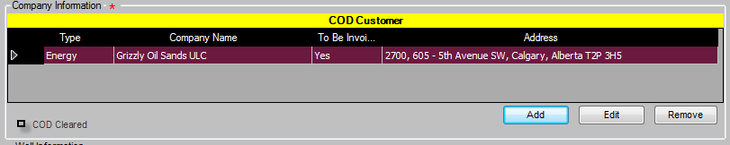

1. **User Story:** Update Rig information to link up with Rig Database
2. Change Rig Number to Dropdown list
3. Add “Rig Name” textbox , “Is Top Drive” checkbox , Size dropdown list, Thread Type dropdown list
4. Change Rig Contractor, Rig Number as cascading dropdown list, when select a Rig Contractor, Rig Number will populate with the rig number of active rigs in Rig Database, Is Top Drive and Rig Name, Size, Thread Type will be populated.
5. If there is a new rig, user needs to create a new rig from Rig Board before use it.
6. Update rig information, user needs to update an existing rig from Rig Board.
7. Size dropdown list items should be same as following code snippet. (from PlugLoadingHeadInfoPresenter.cs)



1. Thread Type dropdown list items are from CommonApplicationController.DrillingThreadTypes;.
2. All fields are editable, and if manually entered record, a new rig will be added to rig database automatically.



1. **User Story**: Add flag a haul needed.

Add a check box “Need Haul?” to product page for each blend editing page.

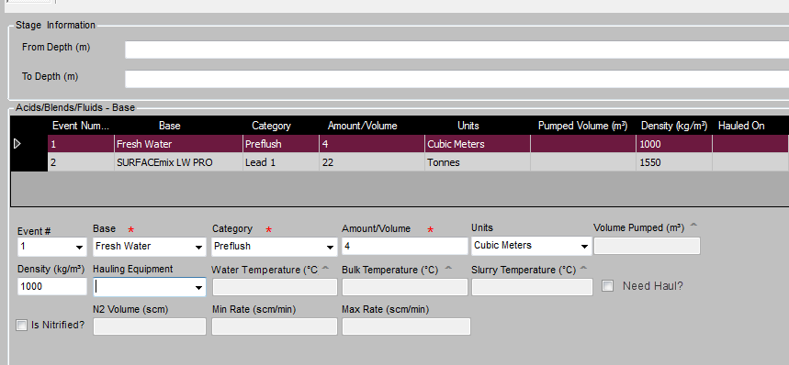

1. **User Story:** Add bin requirements
2. Add a check box “Need Bins?” and a textbox Number of Bin to Unit Personnel page Sanjel Storage Equipment section.
3. Add call sheet validation for ready status, to check the number of bins added in Sanjel Storage Equipment meet the needed number

Notes: 1124目前的实现是当Sanjel Storage Equipment中的Bin的数量大于或者等于输入的Number of Bin的数量时，认为验证通过，是否正确。Sanjel Storage Equipment中的Bin的数量是否可以多余需要的数量？

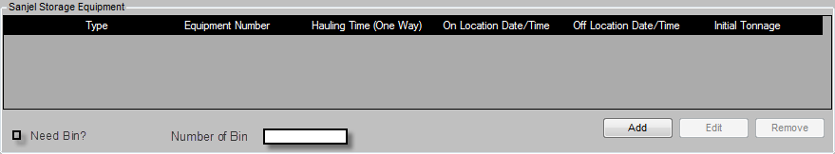

1. User Story: Add “Call Crew Time”
   1. Add a date time box “Call Crew At Date/Time” in call sheet “Call Information (Call Out)” section.
   2. Add a check box “Is this call made?”.

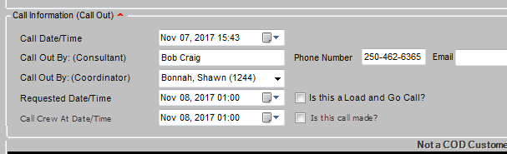

Behavior

1. They are enabled/disabled with the whole section together.
2. Call Crew At Date Time cannot be earlier than Call Date/Time.
3. If “Is this call made”, All other fields are disabled, no change allowed.
4. User Story: Validate Call Sheet Readiness

When save a call sheet, we add a new validation to the rules.

There must be more than one record which “Product or Equipment Haul?” is not checked in “Crew and Units” section.

Error message: “At least one unit not for hauling is required”.

